# 

# 

# 

# 

# 

# **Introduction to Software Engineering Final Report**

By: Andrew Nguyen , Ernest Teamer, Keaton Alexander, Hassan Alsaman , Daniyal Raoofi

# 2.1

We have 5 members in our group. Earnest Teamer, Andrew Nguyen. Daniyal Raoofi, Hassan Alsalman , Keaton Alexander and we are using a Democratic Team team model. Each team member was assigned a role evenly for the following:

**Andrew and Earnest:** Design Implementation ( Programming )

**Hassan and Keaton:** Documentation

**Daniyal :** UML Diagram & Powerpoint

The specifications of this project includes:

* Designing a Graphical User Interface
* Link the GUI to a database that holds all the information regarding academic records.
* Add use cases for both students and teachers with each to have a specific user view.
* The student would be able to enroll in classes, and view their grades, and view their GPA according to their grades.
* Teachers are referred to as Admin in our software, and they’re able to insert, update, and monitor the whole process.
* The students can log in via a username and password, and they can only view their information and not able to perform changes.

|  |  |
| --- | --- |
| **Different phases** | **Activities performed in each stage** |
| **Requirement Gathering stage** | * We gathered the requirements from the project description posted on bb.uhd.edu for Software Engineering Class. |
| **Design Stage** | * We decided to use two programming languages to create the software, then decide which application is more efficient: * First choice was using Visual Basics programming language in parallel with Microsoft Access as a database. * Second choice was using C# in .NET framework, in parallel with MySQL. |
| **Built Stage** | * At this Stage, we started coding the program, by dividing the work among team members. |
| **Test Stage** | * In this phase, you test the software to verify that it is built as per the specifications given by the Professor Chang. |
| **Deployment stage** | * Deploy the project in the built environment, by presenting it to class on Monday 11/25/2019. |
| **Maintenance stage** | * At this point, the software is complete, and we regulate maintenance period or apply changes per client’s request. |

**Use-Case Diagram:**

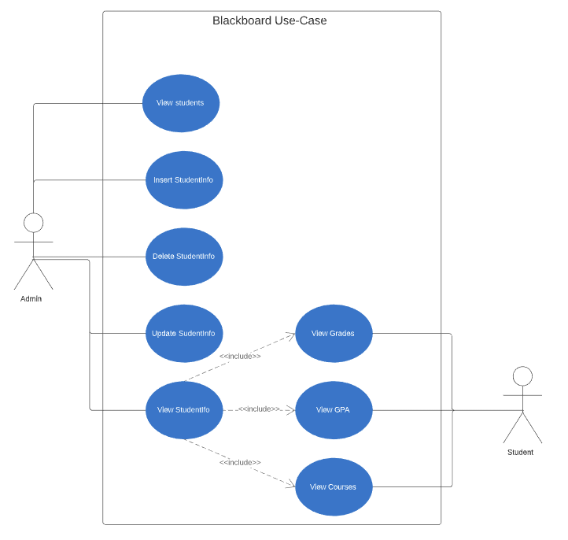

**Class Diagram:**

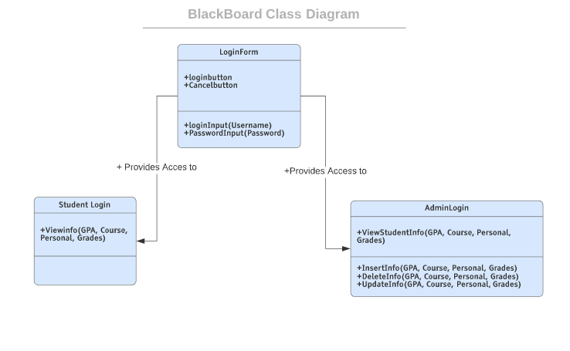

**USE CASE:**

Use case name: **View student records/info**

Actor/User: Admin, Student

Steps:

1. User clicks on “student login” or “admin login”
2. User enter’s “student Username” and “Password” or if admin: User enter’s “admin Username” and “Password”
3. User clicks “login button”

Once logged on:

1. User views “grades”

2. User views “Courses”

3. User views “GPA”

4. User views “name & ID”

User can click exit to logout.

Use case name: **Entering a new Student**

Actor/User: Admin

Steps:

1. User clicks on “View Student” button.

2. System displays an entry screen with new user id generated and prompts the user to enter first name, last name, Student ID, Courses, Grades and calculate the GPA.

3. User clicks on “ADD Student” button.

4. System creates new student record in the database.

Use case name: **Updating an existing student**

Actor/User: admin

Steps:

1. User clicks on “Student number” button.

2. System displays the students information screen and prompts the user to input the updated information

3. Once updated the system allows the User to save by clicking “Save Student Data” button

4. User has the option to update other students as well by their enrollment number.

5. When finished user can use “exit” to logout.

Use case name: **Deleting an existing student**

Actor/User: admin

Steps:

1. User enter on the “enrollment #” to choose the targeted student .

2. User selects “ Delete Student Data” to delete the student.

3. System asks User if he is sure, User can select “yes”

4. Student is deleted from the database.

5. When finished user can use “exit” to logout.

# 

# 2.2 . Please refer to powerpoint attached

# 2.3 All artifacts you used in the project, please refer to folder for all resources

**Tools Used**: Discord, GroupMe , Trello, SQL Server Management Studio, LucidChart, GitHub, Visual Studio , .NET Framework C# , Google Documents, Gmail, Google.com, MS Office Suite, Teamviewer

2.4 Conclusion  
Over all the program was a complete success, the groups effort came through and we have an up and running blackboard on the SQL Server. Our future goals are to modify and make it an online version of the program and to make it more secure from threats, we will also add more admins and another class for teachers to access and be able to assign and modify grades but not able to add or delete students off the database.